1. For different category of acquirers, what is the average number of months since the inception of the acquired company after which they are acquired.​

SELECT

acq.acquirer_category_code,

AVG(

(CAST(acq.acquired_at AS DATE) - CAST(comp.first_funding_at AS DATE))/30

) AS average

FROM

tutorial.crunchbase_companies AS comp

INNER JOIN

tutorial.crunchbase_acquisitions AS acq

WHERE

acq.acquirer_category_code IS NOT NULL

ON

acq.company_permalink = comp.permalink

GROUP BY

acq.acquirer_category_code

1. Is there any trend for quarters when more companies are acquired ?

SELECT

RIGHT(acquired_quarter,2) AS Quater,

COUNT(company_permalink) AS cnt

FROM

tutorial.crunchbase_acquisitions

GROUP BY

Quater

ORDER BY

cnt DESC;

1. For each company_category_code identify the average raised_amount_usd per quarter​

SELECT

company_category_code,

RIGHT( funded_quarter,2) AS quater,

AVG(raised_amount_usd)

FROM

tutorial.crunchbase_investments

WHERE

funded_quarter IS NOT NULL AND raised_amount_usd IS NOT NULL

GROUP BY

company_category_code,quater

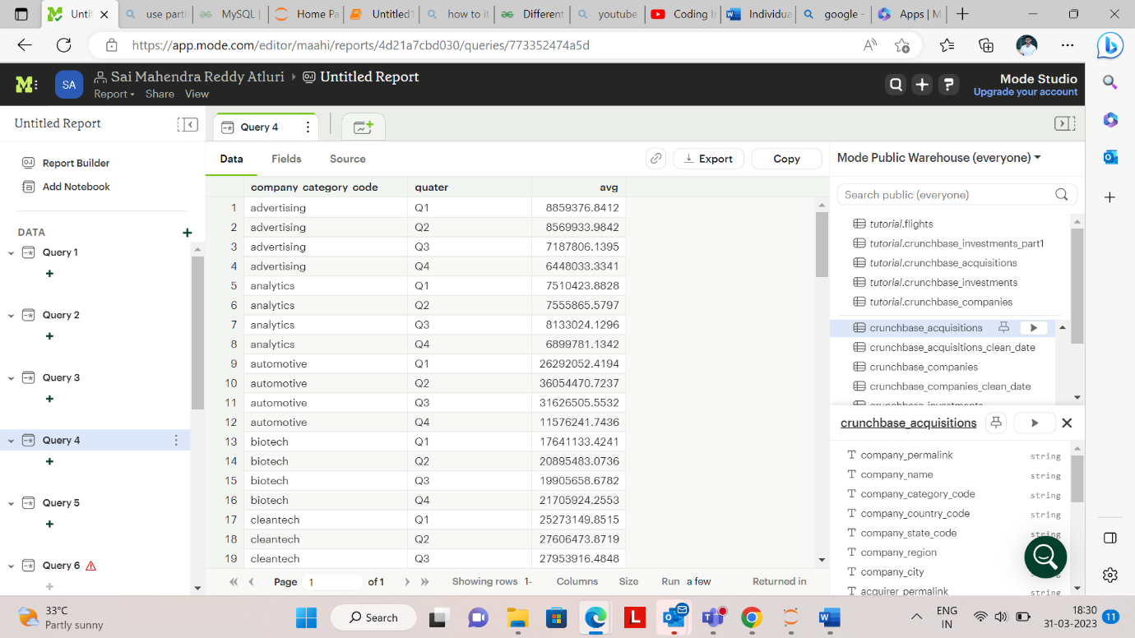

1. Which investor (company ) is more likely to invest in USA based companies?​

SELECT

investor_name,

COUNT(company_name) AS cnt

FROM

tutorial.crunchbase_investments

WHERE

company_country_code LIKE 'USA' AND

investor_name IS NOT NULL

GROUP BY

investor_name

ORDER BY

cnt DESC;

1. For different type of funding rounds, what is the average raised amount per quarter​

SELECT

funding_round_type,

RIGHT(funded_quarter,2) AS quarter,

AVG (raised_amount_usd)

FROM

tutorial.crunchbase_investments

WHERE

funding_round_type IS NOT NULL

GROUP BY

funding_round_type,

quarter;

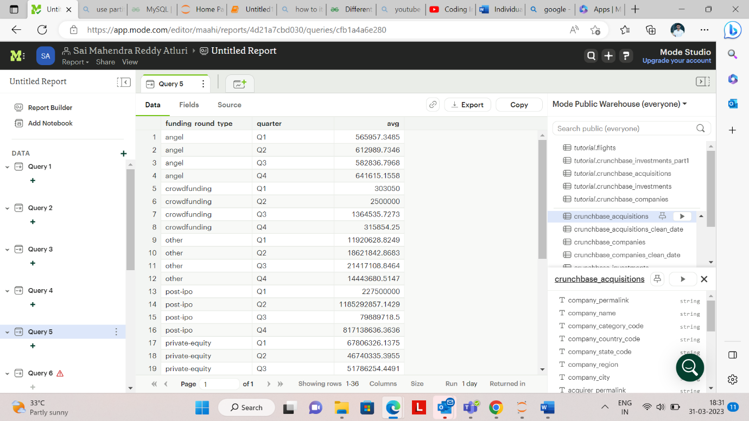

6. Identify companies that received an investment from Japan following an investment from Great Britain where investor is finance category company​

SELECT

s.company_name

FROM(

SELECT

company_name,

investor_category_code,

investor_country_code,

LEAD(investor_country_code) OVER(ORDER BY CAST(funded_at AS DATE)) AS next

FROM

tutorial.crunchbase_investments

) AS s

WHERE

s.investor_category_code LIKE ('finance') AND

s.investor_country_code IN ('JPN') AND

s.next LIKE('GBR');

1. Out  of all 'operating' status companies, which category of companies have the highest average funding_total_usd?​

SELECT

category_code,

AVG( funding_total_usd) AS average

FROM

tutorial.crunchbase_companies

WHERE

status LIKE 'operating' AND funding_total_usd IS NOT NULL AND category_code IS NOT NULL

GROUP BY

category_code

ORDER BY

average DESC;

1. For each category, what percent of companies received funding within 3 years of their founding?​

SELECT

category_code,

(COUNT(CASE WHEN (CAST(first_funding_at AS DATE) - CAST(founded_at AS DATE))/365 <= 3 THEN 1 END) *100) / COUNT(*) AS percentage

FROM

tutorial.crunchbase_companies

WHERE

category_code is NOT NULL

GROUP BY

category_code;

1. Clean the 'last_funding_at' column (convert it to time stamp) and get the time difference with the current time.​

SELECT

CAST(last_funding_at AS timestamp) AS las,

(NOW() - CAST(last_funding_at AS timestamp)) AS time_difference

FROM

tutorial.crunchbase_companies;

1. Provide additional analysis based on the data in crunchbase tables​.

SELECT

COUNT(DISTINCT company_name) AS no_of_invested_companies,

investor_name

FROM

tutorial.crunchbase_investments

GROUP BY

investor_name

ORDER BY

no_of_invested_companies DESC;

Y Combinator , SV Angel are the top investors investing in 400+ companies.

